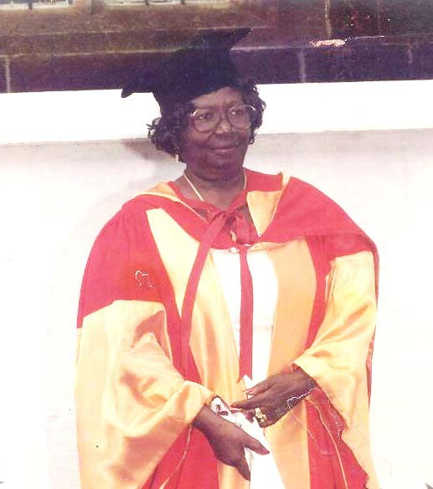
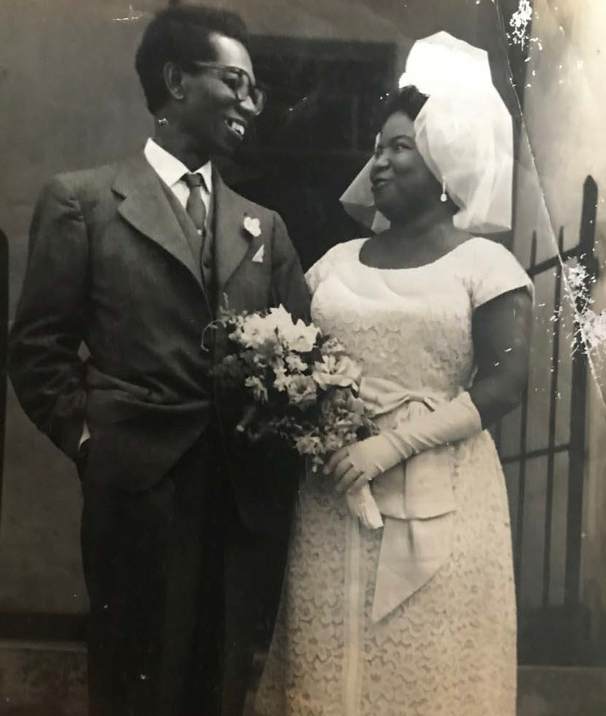
Memorial and Communion Service for The Late
Dr. TALABI AISIE LUCAN

Notes:

The family of the late Drs. Ebenezer and Talabi Lucan would like to applaud your support and wish you to know that you are all greatly appreciated. The path has been tough and regularly uphill, but you have been there ready with a supporting hand and much more.
Sunrise: 12/4/1921 Sunset: 3/22/2017 Sunday 25TH March 2018
Colesville United Methodist Church 52 Randolph RD, Silver Spring 20904

Officiating Clergies Rev. Gloria Cline-Smythe Rev. Cannon Prince-Decker
Rev. Ernest Williamson-Taylor
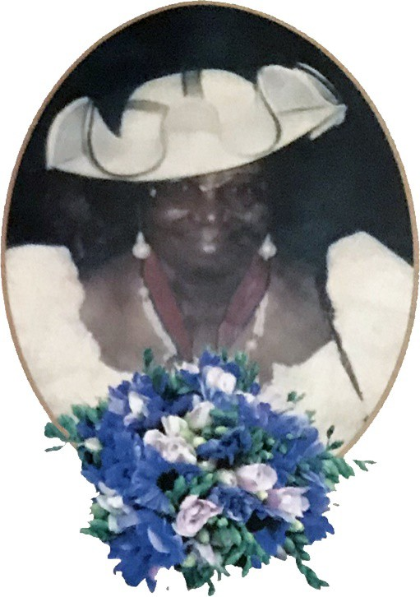

TRIBUTE
For our mother, our best friend
If Only we could have one more Day
we would tell you how much we love you,
How much joy you gave us,
And how you made us feel safe.

You were the Greatest,
You are always there, Mama
No one will ever know quite how we feel inside.

Thank you for loving us unconditionally
our heart is lonely, but we take our strength from
God Almighty
our sweet memories of you always keep us going
we will never forget you, Mama
Be safe in the hands of Jesus and feel pain no more Until we meet again to apart no more.

FAREWELL

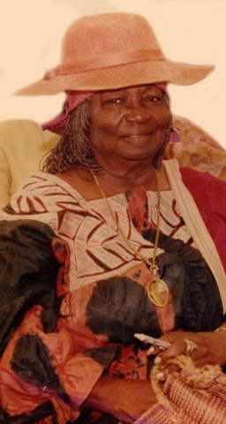
Family Photos
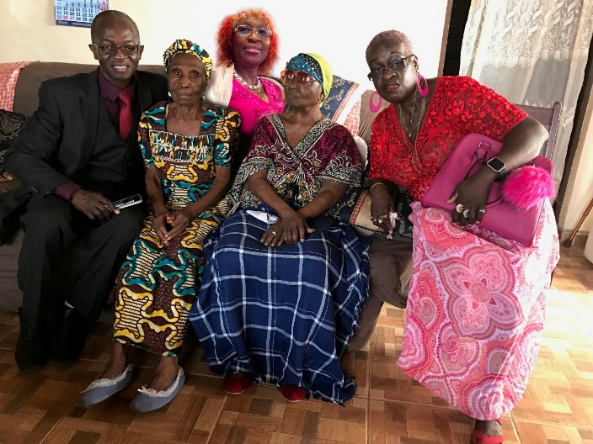

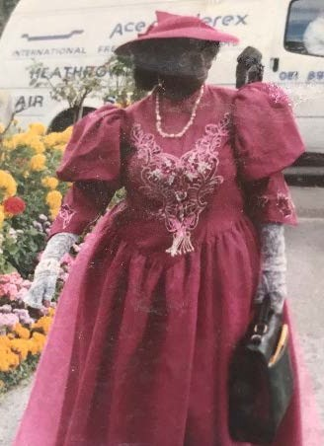

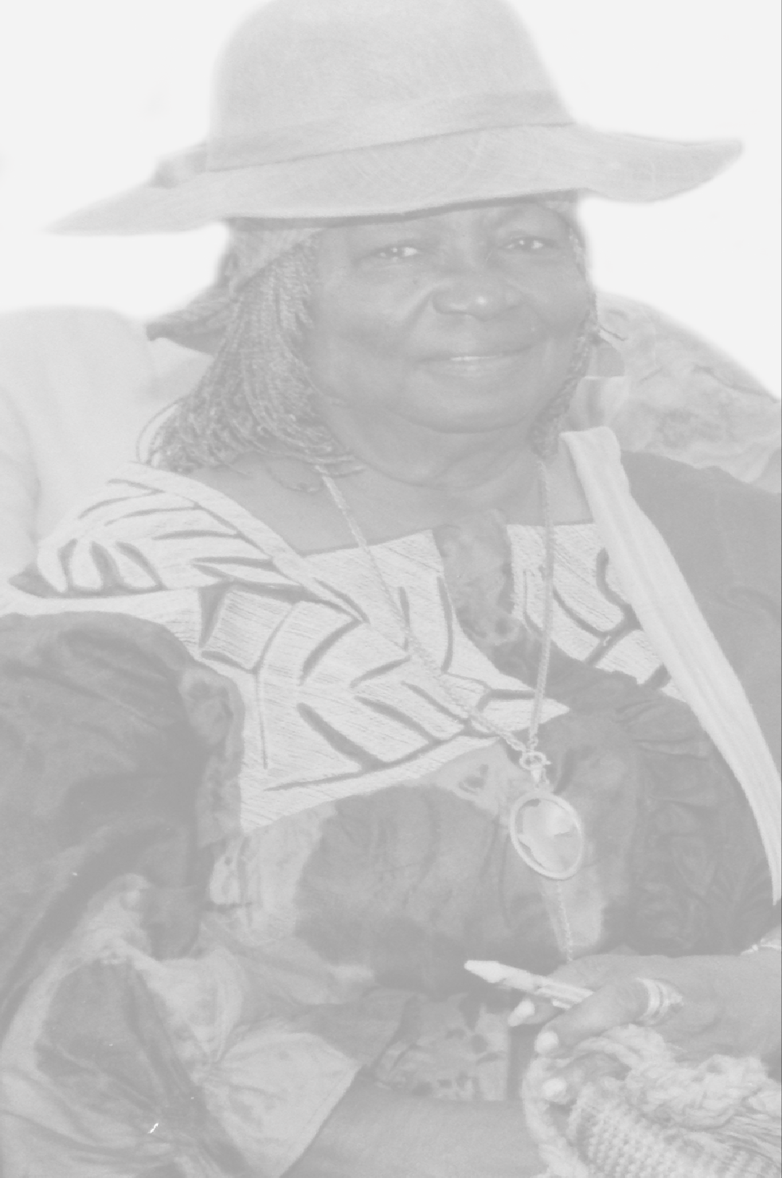

When Peace Like A River
When peace, like a river, attendeth my way,
when sorrows like sea billows roll;
whatever my lot, thou hast taught me to say,
It is well, it is well with my soul.
Refrain:
It is well with my soul,
it is well, it is well with my soul.
Though Satan should buffet, though
trials should come,
let this blest assurance control,
that Christ has regarded my helpless estate,
and hath shed his own blood for my soul.
(Refrain)
My sin, oh, the bliss of this glorious thought!
My sin, not in part but the whole,
is nailed to the cross, and I bear it no more,
praise the Lord, praise the Lord, O my soul!
(Refrain)
And, Lord, haste the day when my faith
shall be sight, the clouds be rolled back as a scroll;
the trump shall resound, and the Lord shall descend,
even so, it is well with my soul.
(Refrain)

Order of Service
- Musical prelude
- Lighting of Memorial Candle
- Welcome
- Hymn # 1 – Now Praise We Great and Famous Men
- Opening Prayer
- Old Testament Reading – Isaiah 25:6-9
- Tributes
- New Testament Reading – Hebrews 10:1-12
- Holy Gospel St. Luke 13:18-19
- Homily by Rev. Gloria Cline-Smythe
- The Great Thanksgiving
(FOLLOW ORDER OF COMMUNION IN THE RED HYMN BOOK)
- Hymn # 2 – When Peace Like A River
- Offering
- Closing Courtesies BLESSING OF THE FOOD
AWUJOH

Now Praise We Great and
Famous Men
Now praise we great and famous men,
The fathers named in story;
And praise the Lord, Who now as then Reveals in man His glory.

Praise we the wise and brave and strong,

Who graced their generation,
Who helped the right, and fought the wrong, And made our folk a nation.

Praise we the great of heart and mind,
The singers sweetly gifted,
Whose music like a mighty wind
The souls of men uplifted.

Praise we the peaceful men of skill,
Who builded homes of beauty,
And, rich in art, made richer still
The brotherhood of duty.
Remembering
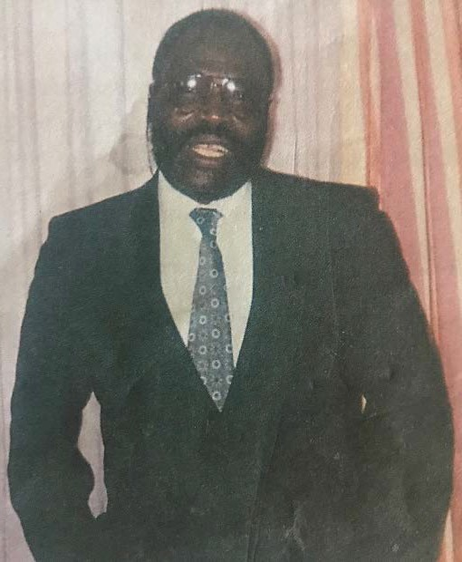

Our Loving Brother
Dr. Conrad Horace
Olufemi Lucan
19th September 1943
20th March 2015

And
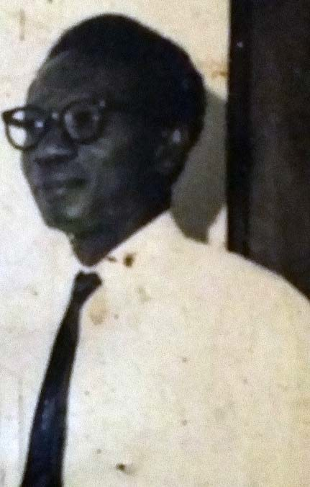

Our Loving Father
Dr. Ebenezer
Veresmond Onike Lucan
30th September 1911
31st March 1999

