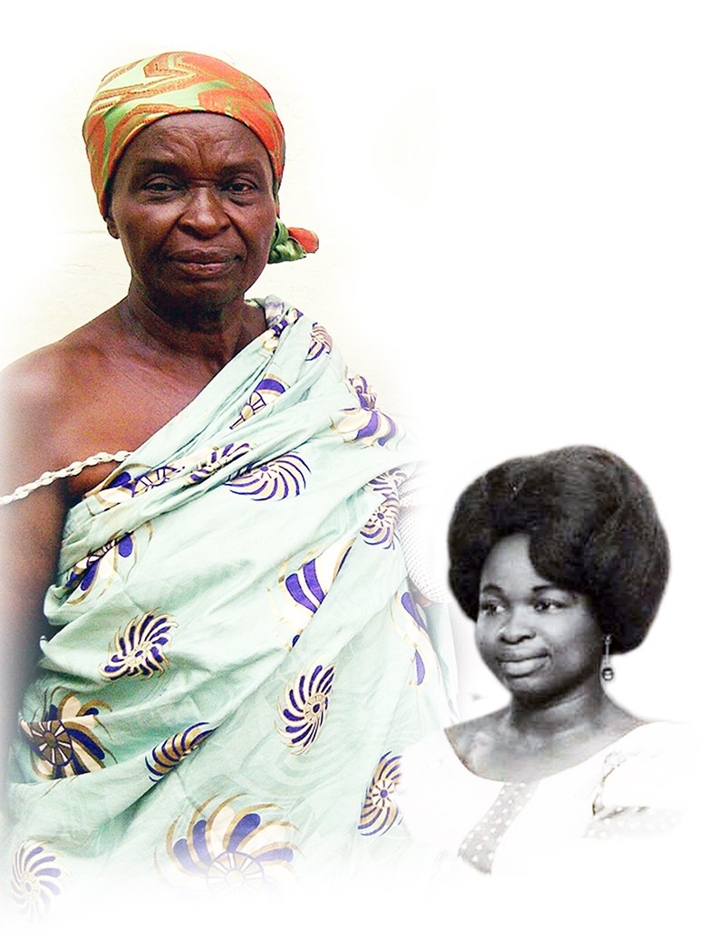
Celebration
of Life
our beloved

Mad. Martina Edusei
alias Nana Owusuaa

Saturday April 19, 2014
Russett Community Center
3500 Russett Common
Laurel, MD 20724
7pm-12am
Contact: 202 683 0040
for info and directions

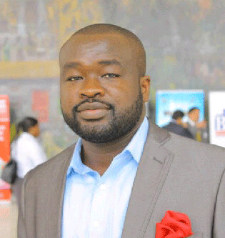

Kwaku Boakye (son)
All are cordially invited

